College LaSalle
Project – Web Client Development Technical Manual
Presented to: Mihai Maftei

Author: Puneet Kaur
10/3/2025
Version: 3.0

Start by adding a short description of your project, and the languages (technologies) used
Description: The website is about cosmetic products
- Languages: XHTML
- HTML5
- CSS
- JavaScript
- JQuery

Presenting how the files/folders are organised.
- Index.html
  - Content.htm
  - Top.htm
  - Menu.html
  - MenuT.htm

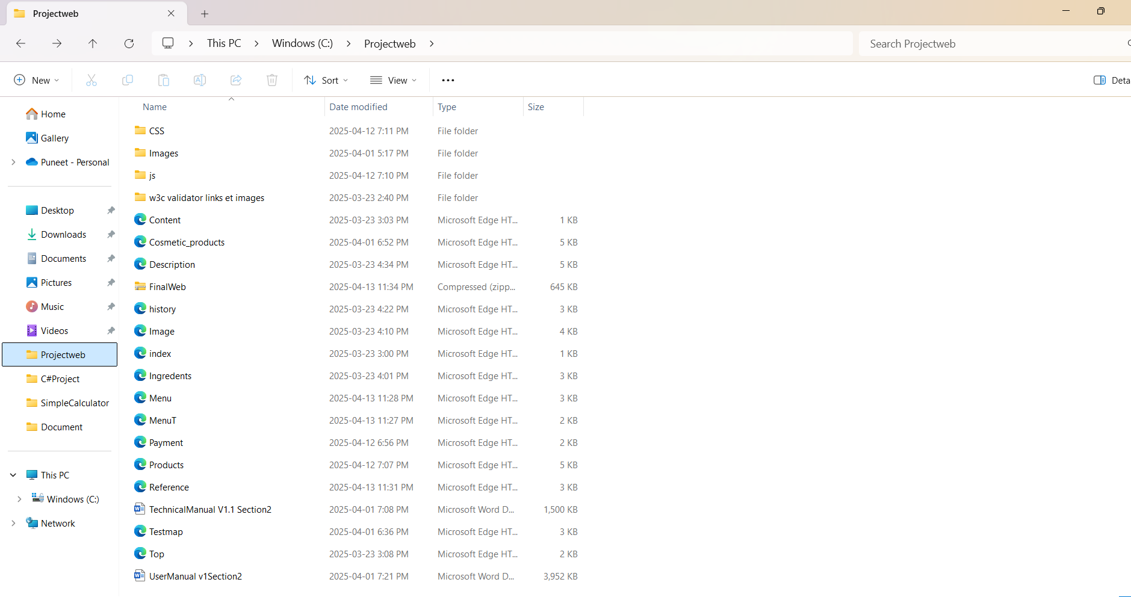
- Css
  - Mystyles.css
  - Payment.css
  - Product.css
  - Style1.css
  - Styles1.css
  - Testmap.css
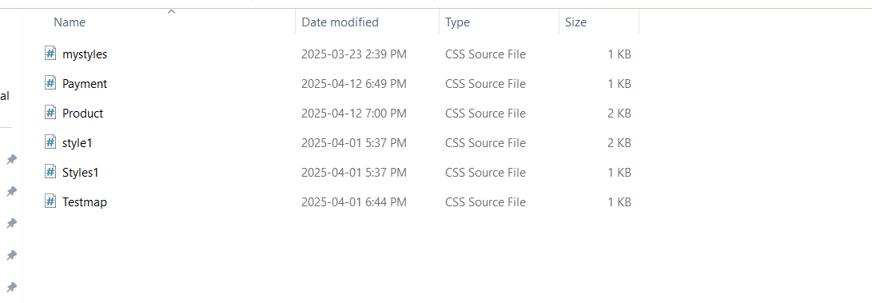

- Images
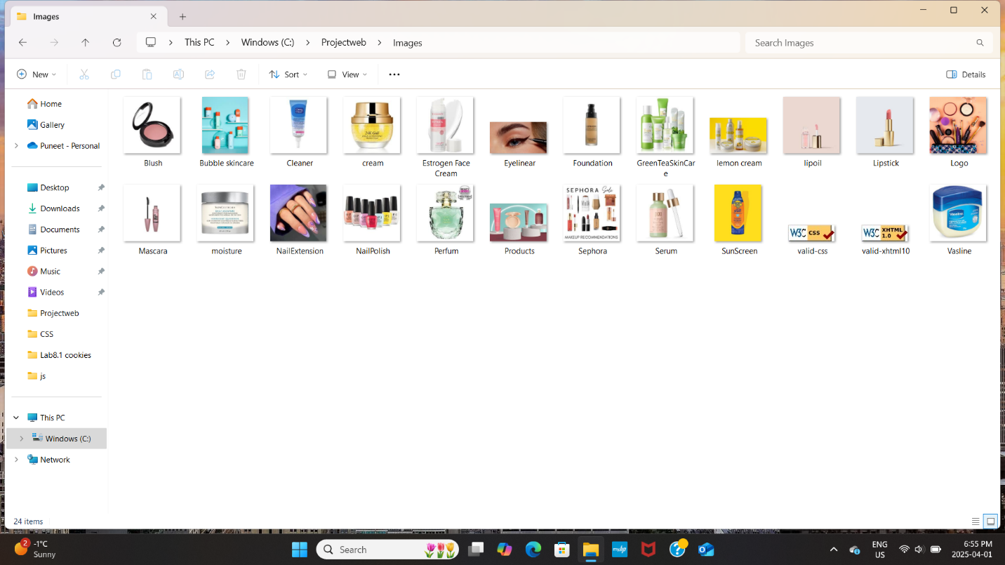
- JS
  - Login
  - jQuery-3.6.1.min
  - Payment
  - Product
  - Scripts1
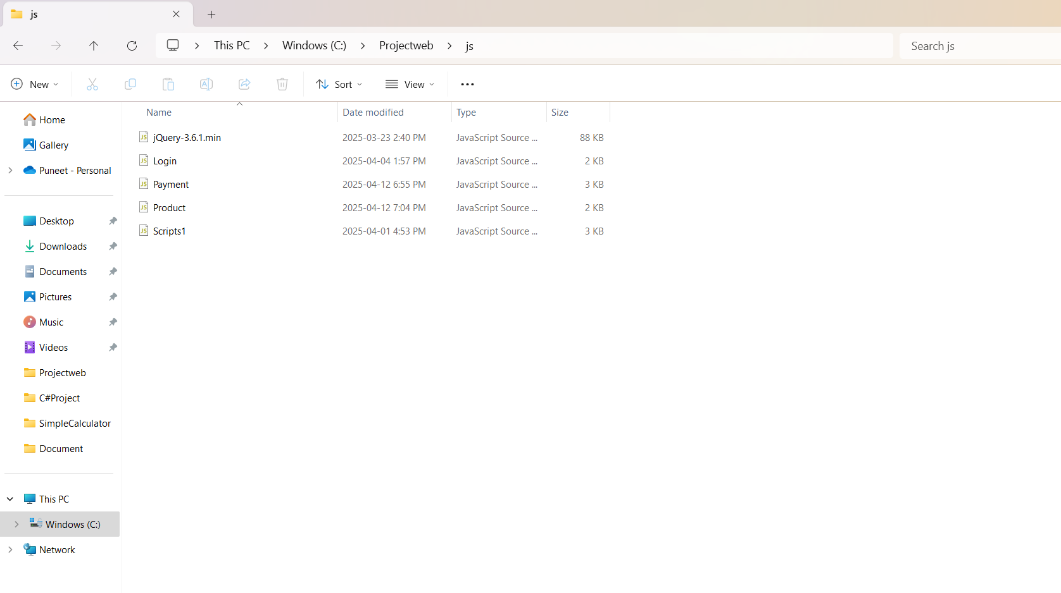

Presenting how your web pages are organized the web elements:

Present the functions and/or methods that you create, or you did use in web project.
Function/Method Name | Short description
- document.getElementById() | Returns the object identified by its ID.
- alert(mess) | Displays a message in an external window.
- validateLogin() | Validates user login credentials.
- toggleMenu() | Toggles the visibility of the navigation menu.
- updateCart() | Updates the shopping cart dynamically.

Present the difficulties that you have, what was the hardest and the easiest part of your project.
Easy for me on the section 1:
Implementing basic HTML and CSS structure.
Hard for me on section 1:
JQuery
Difficulties:
Date: …2025-03-19 login and logout Problems
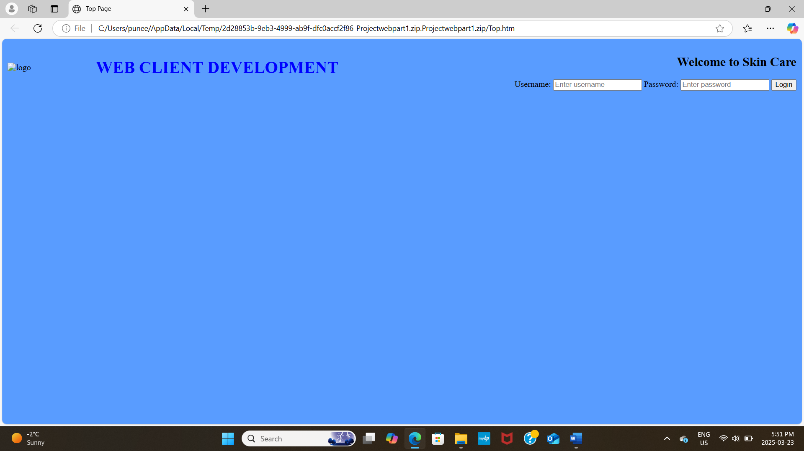

Date: 2025-03-22
Solve the problem and correct it

